**12.6.1 Ant on a Chessboard**

**Code:**

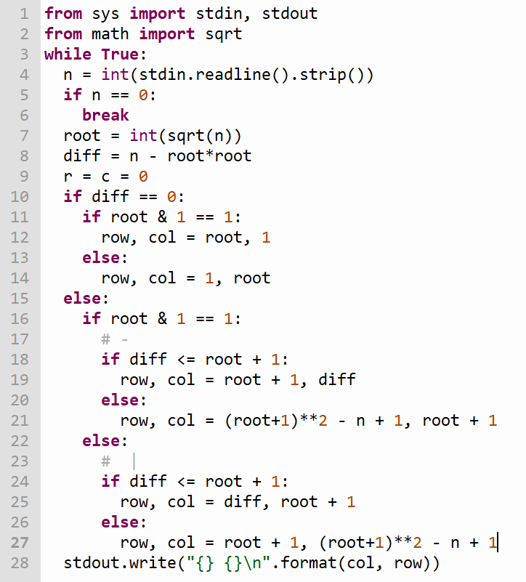

**Output:  
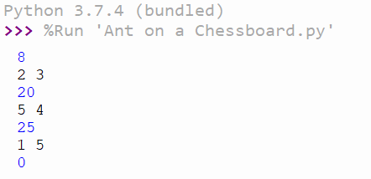**

**12.6.7 Dermuba Triangle**

**Code:  
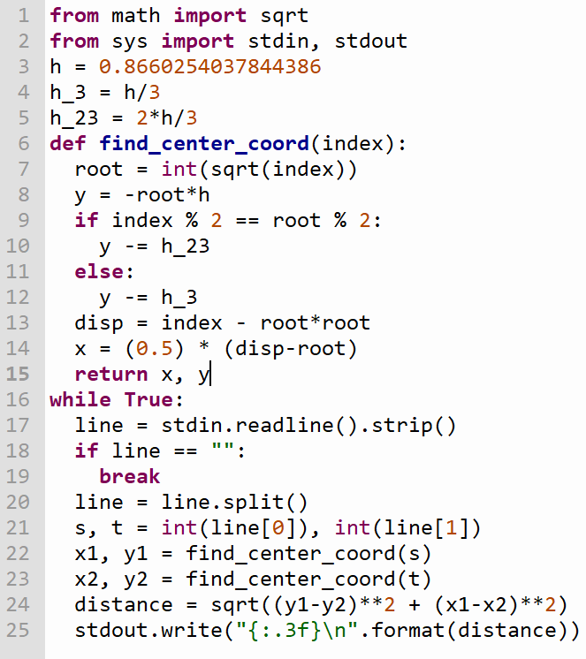**

**Output:  
